Avoided Energy Use Analysis for Millennium Tower

09 February, 2021

## Data Summary

|  |  |
| --- | --- |
|  | Utility Data Specification |
| eload | Electricity |
| Source | Seattle City & Light |
| Received Date | 02/02/2021 |
| Data Interval | 15 min |
| Start Date | 01/01/2019 00:15 |
| End Date | 12/31/2020 23:45 |
| # Missing Data Points | 0.0 |
| # Total Data Points | 69,965.0 |

|  |  |
| --- | --- |
|  | Temperature Data Specification |
| Weather Station | Boeing Airfield |
| Approx. Distance to Site | 5 mi |
| Data Download Date | 02/08/2021 |
| Data Interval | 60 min |
| Start Date | 01/01/2019 00:00 |
| End Date | 12/31/2020 23:00 |
| # Missing Data Points | 60.0 |
| # Total Data Points | 17,532.0 |
| TMY data available? | Yes |

|  |  |
| --- | --- |
|  | Hours/Day with Missing Temperature Data |
| 2019-01-06 | 4 |
| 2019-03-20 | 5 |
| 2019-03-24 | 7 |
| 2019-03-25 | 9 |
| 2019-03-26 | 7 |
| 2020-10-23 | 4 |
| 2020-10-25 | 4 |
| 2020-11-02 | 4 |

|  |  |  |
| --- | --- | --- |
| Modeling Period | Start | End |
| Baseline | 01/01/2019 00:00 | 12/31/2019 23:45 |
| Performance | 01/01/2020 00:00 | 12/31/2020 23:45 |

## Baseline Period Model

|  |  |  |  |  |  |  |  |  |
| --- | --- | --- | --- | --- | --- | --- | --- | --- |
| Period | Model | Interval | R^2 | Adjusted R^2 | CV(RMSE) % | NMBE % | Uncertainty for 10% Savings | CL |
| Baseline | TOWT | Daily | 0.86 | 0.85 | 9.97 | 0.000 | 0.120 | 90 |

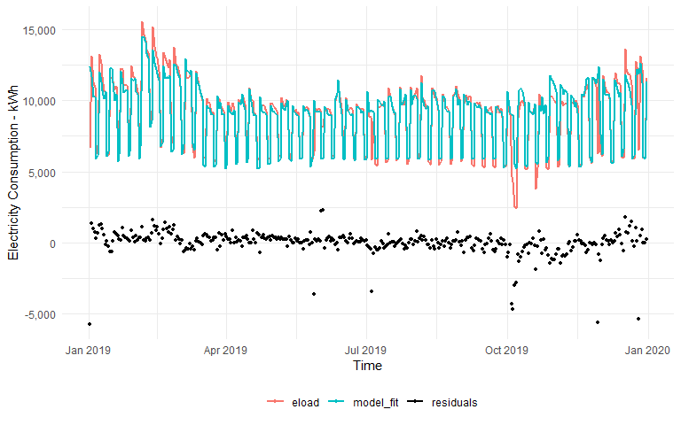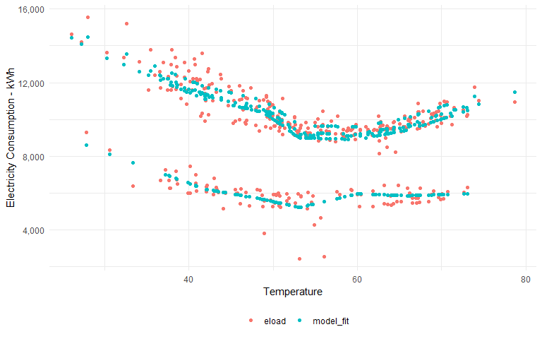

## Avoided Energy Use

If additional independent variables were used in the analysis, the avoided use is calculated based on the models developed with the additional variables.

|  |  |  |  |  |  |  |
| --- | --- | --- | --- | --- | --- | --- |
| Perf. Period Use | Adjusted Baseline | Expected Avoided Use | Savings | Savings Fraction | Savings Uncertainty | CL |
| 3162638 | 3291582 | 1089101 | 128943.8 | 0.04 | 0.3012171 | 90 |

